Setting up LangSmith projects

Step 1 — Install LangSmith
pip install -U langsmith
Step 2 — Create a LangSmith account
Step 3 — Create the project
Tracing → Projects → New Project
Step 4 — Create your API key
Step 5 — Put configuration in .env
GOOGLE_API_KEY=YOUR_GOOGLE_API_KEY

LANGSMITH_TRACING=true
LANGSMITH_API_KEY=YOUR_LANGSMITH_API_KEY
LANGSMITH_PROJECT=loan-rag-project
Step 6 — Load .env in Python
from dotenv import load_dotenv

load_dotenv()
Step 7 — Enable tracing
from langsmith import traceable
@traceable
def ask_rag(question: str):
Step 8 — Run your application
Step 9 — Open LangSmith
Tracing → loan-rag-project

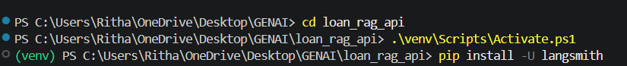

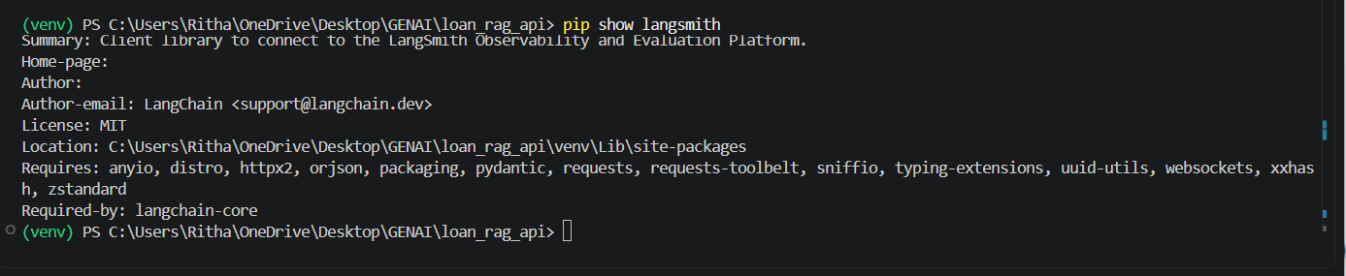
(venv) PS C:\Users\Ritha\OneDrive\Desktop\GENAI\loan_rag_api> pip install python-dotenv
.env
GOOGLE_API_KEY=****b8RN6JukkdZPi5cOaM6aPQcsivTIQCHjPGEdCOVYB8AzU****

LANGSMITH_TRACING=true
LANGSMITH_API_KEY=****_pt_452d744d795146e0862e6330a0fa3071_2ae6d5****
LANGSMITH_PROJECT=loan-rag-project

rag.py
from dotenv import load_dotenv
load_dotenv()

from langsmith import traceable

from langchain_huggingface import HuggingFaceEmbeddings
from langchain_chroma import Chroma
from langchain_google_genai import ChatGoogleGenerativeAI

# --------------------------------------------------
# 1. Create the SAME local embedding model
# --------------------------------------------------

embeddings = HuggingFaceEmbeddings(
model_name="sentence-transformers/all-MiniLM-L6-v2"
)

# --------------------------------------------------
# 2. Connect to our existing ChromaDB
# --------------------------------------------------

vectorstore = Chroma(
persist_directory="./chroma_db",
embedding_function=embeddings
)

# --------------------------------------------------
# 3. Create Gemini through LangChain
# --------------------------------------------------

llm = ChatGoogleGenerativeAI(
model="gemini-3.6-flash"
)

# --------------------------------------------------
# 4. RAG function
# --------------------------------------------------

@traceable
def ask_rag(question: str):

# Search ChromaDB for relevant chunks
results = vectorstore.similarity_search(
question,
k=3
)

# Combine the retrieved chunks
context = "\n\n".join(
doc.page_content
for doc in results
)

# Create the prompt for Gemini
prompt = f"""
You are a helpful loan policy assistant.

Answer the user's question using ONLY the information
provided in the context below.

CONTEXT:
{context}

QUESTION:
{question}

If the answer is not available in the context,
say:

"The information is not available in the loan policy."
"""

# Send prompt to Gemini through LangChain
response = llm.invoke(prompt)

return response.content

# --------------------------------------------------
# 5. Test the RAG system
# --------------------------------------------------

if __name__ == "__main__":

question = "What is the minimum age for a personal loan?"

answer = ask_rag(question)

print("\nQuestion:")
print(question)

print("\nAnswer:")
print(answer)

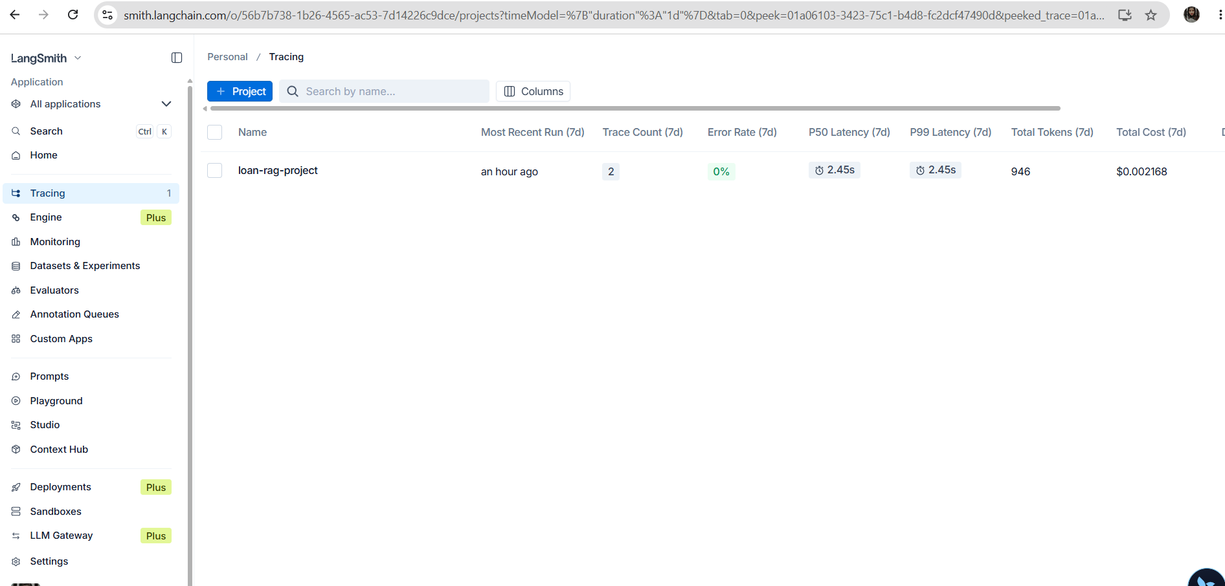

Click on loan_rag_project

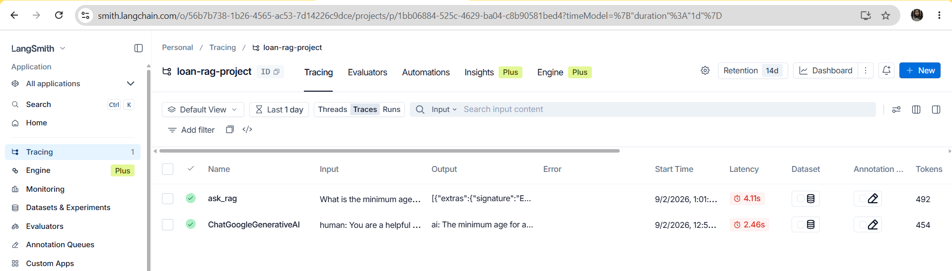

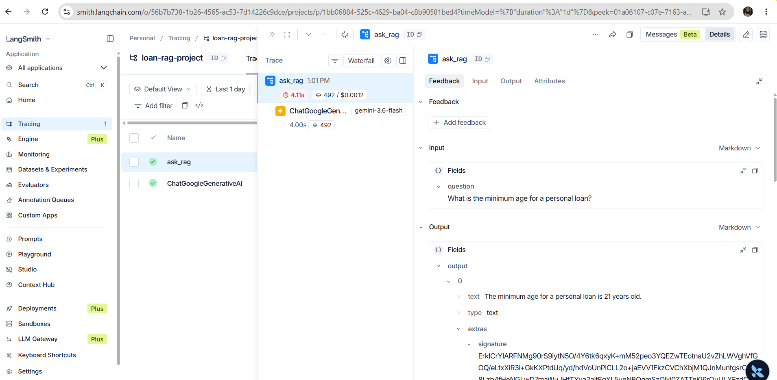

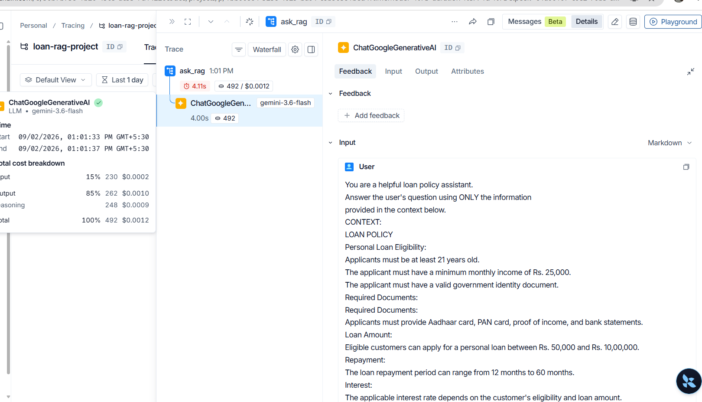

“I used LangSmith to monitor my Loan RAG application. I created a project called loan-rag-project and enabled LangSmith tracing through the .env file. I used the @traceable decorator to track my RAG function. When I asked a question about the minimum age for a personal loan, LangSmith recorded the input, output, execution time, token usage, cost, and Gemini model execution. This helps developers debug, monitor, evaluate, and improve RAG applications.”

